BUG 1
Bug ID:
Bug Summary:
First Name field accepts numeric and special characters
Bug Description:
System accepts first name containing numeric and special characters (e.g., suhavi@1), whereas it should restrict input to alphabets only.
Steps to Reproduce:
- Navigate to Registration page
- Enter First Name: suhavi@1
- Fill all other fields with valid data
- Click on Register Button.
Actual Result:
System accepts the invalid first name and allows registration to proceed.
Expected Result:
System should display error message: “First Name should contain only alphabets”
Severity: High
Priority: High
Attachments:
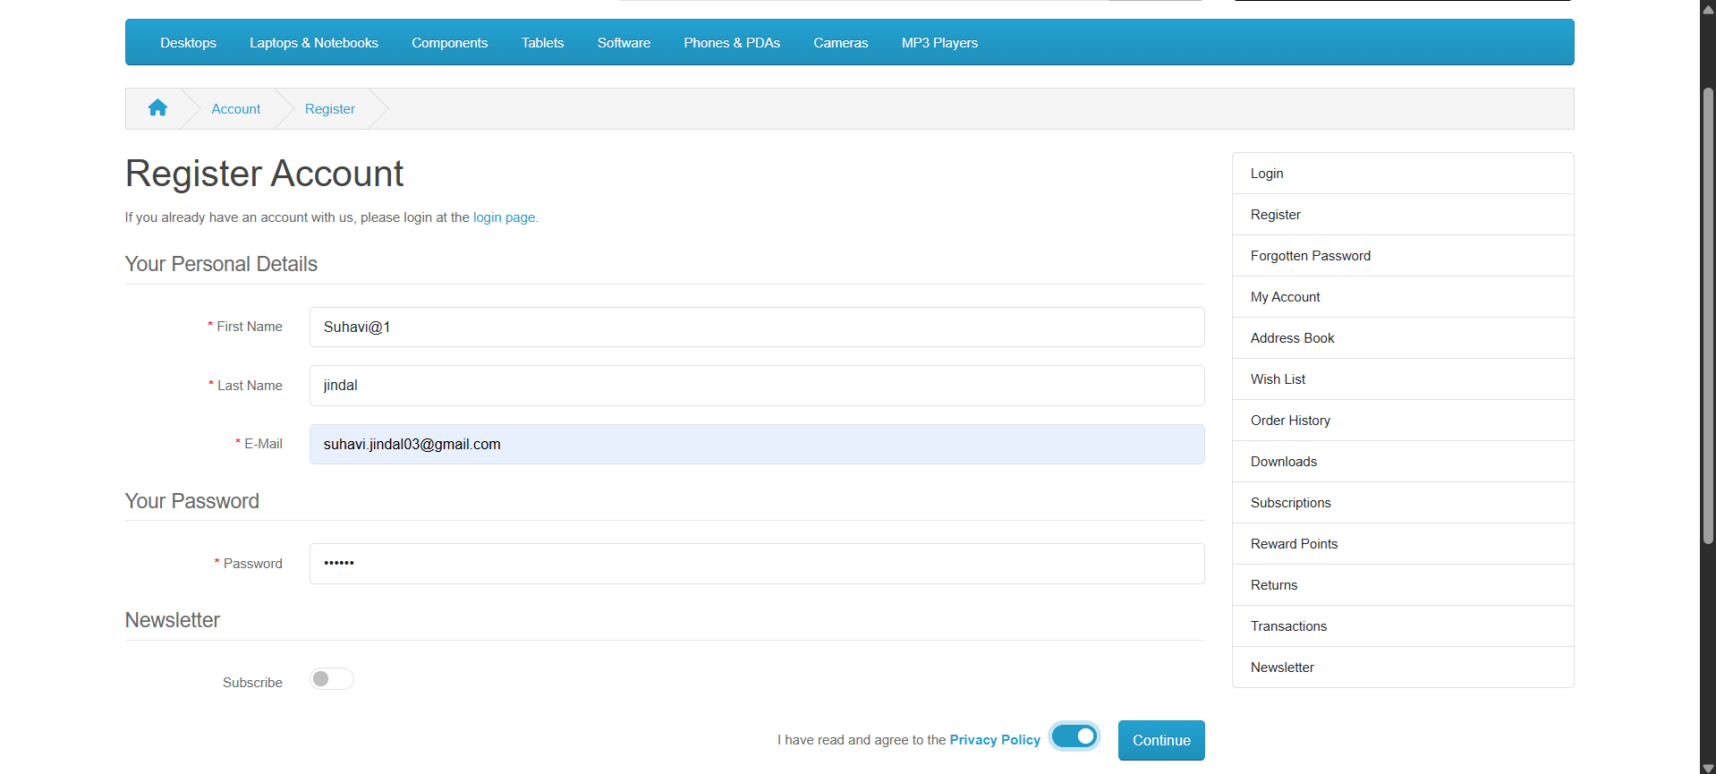

BUG 2
Bug ID:
Summary:
Last Name field accepts numeric and special characters
Bug Description:
System accepts last name containing numeric and special characters (e.g., Jindal!2).
Steps to Reproduce:
- Navigate to Registration page
- Enter Last Name: jindal@1
- Fill all other fields with valid data
- Click on Register Button.
Actual Result:
System accepts the invalid last name and allows registration to proceed.
Expected Result:
System should display error message: “Last Name should contain only alphabets”
Severity: High
Priority: High

BUG 3
Bug ID:
Bug Summary:
Telephone field is missing on Registration page
Bug Description:
Telephone field is not available on the Registration page, though it is part of the requirement and test cases.
Steps to Reproduce:
- Navigate to Registration page
- Telephone field is missing
- Fill all other fields with valid data
- Click Register
Actual Result:
Telephone field is not displayed.
Expected Result:
Telephone field should be available and mandatory.
Severity: Critical
Priority: High
Attachments:

BUG 4
Bug ID:
Bug Summary:
Telephone validation cases cannot be tested because Telephone field is missing
Bug Description:
All telephone validation scenarios failed because the Telephone field itself is not available.
Steps to Reproduce:
- Navigate to Registration page
- Telephone field is missing
- Fill all other fields with valid data
- Click Register
Actual Result:
Telephone field not present in UI.
Expected Result:
Telephone field should be displayed and support validation for:
- Numeric only
- Exact 10 digits
- No alphabets/special characters
Severity: Critical
Priority: High
Attachments:

BUG 5
Bug ID:
Bug Summary:
System accepts non-complex password
Bug Description:
Password complexity validation is not working properly.
Steps to Reproduce:
- Navigate to Registration page
- Enter Password: 1234
- Fill all other fields with valid data
- Click Register
Actual Result:
Password is not validated as per complexity requirement.
Expected Result:
System should enforce password complexity rules.
Severity: High
Priority: High
Attachments:

BUG 6
Bug ID:
Bug Summary:
No error message displayed for invalid password format.
Steps to Reproduce:
- Navigate to Registration page
- Enter Password :1234
- Fill all other fields with valid data
- Click Register
Actual Result:
System does not display validation message when password lacks uppercase, lowercase, numeric and special characters.
Expected Result:
System should display error: “Password must contain uppercase, lowercase, number and special character”
Severity: Critical
Priority: High
Attachments:

BUG 7
Bug ID:
Bug Summary:
Password maximum length validation not working
Steps to Reproduce:
- Navigate to Registration page
- Enter Password: 123456789456
- Fill all other fields with valid data
- Click Register
Actual Result:
System allows password exceeding maximum length without error.
Expected Result:
Error message: “Password cannot exceed maximum length (10 characters)”
Severity: Medium
Priority: Medium
Attachments:

BUG 8
Bug ID:
Bug Summary:
Password minimum length validation not working
Steps to Reproduce:
- Navigate to Registration page
- Enter Password: 123
- Fill all other fields with valid data
- Click Register
Actual Result:
System does not show validation message for password less than minimum length.
Expected Result:
“Password must be at least 5 characters long”
Severity: High
Priority: Medium
Attachments:

BUG 9
Bug ID:
Bug Summary:
Confirm Password field is missing
Bug Description:
Confirm Password field is not available on Registration page.
Steps to Reproduce:
- Navigate to Registration page
- Confirm Password field is missing
- Fill all other fields with valid data
- Click Register
Actual Result:
Field not displayed.
Expected Result:
Confirm Password field should be available and mandatory.
System should validate password match.
Severity: Critical
Priority: High
Attachments:

